**BridgePrep Academy Summer Home Learning Activities**

* K-5
  + I-Station Reading 30 minutes a day
  + Read 30 minutes a day using a text of your choice
* 6-10
  + Achieve3000 Article per week
  + Read 30 minutes a day using a text of your choice

**Please select novels from approved list below**

Titles have been selected for age appropriate reading level and content; however, parents are encouraged to help their student make a selection by previewing the titles for difficulty of the text, subject matter, and content.

**K-5**

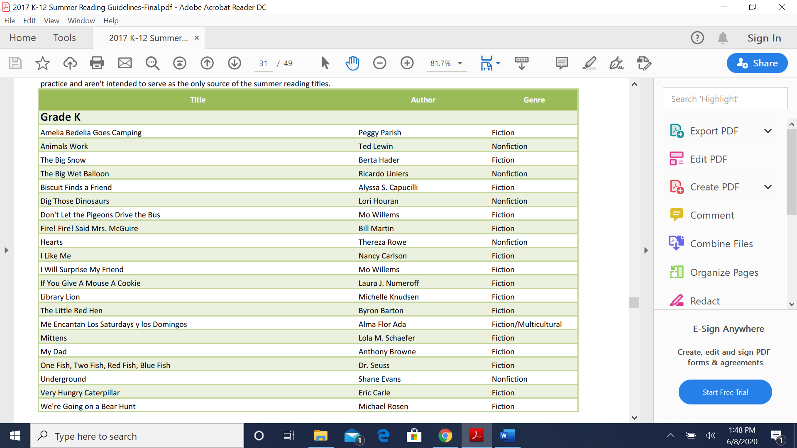

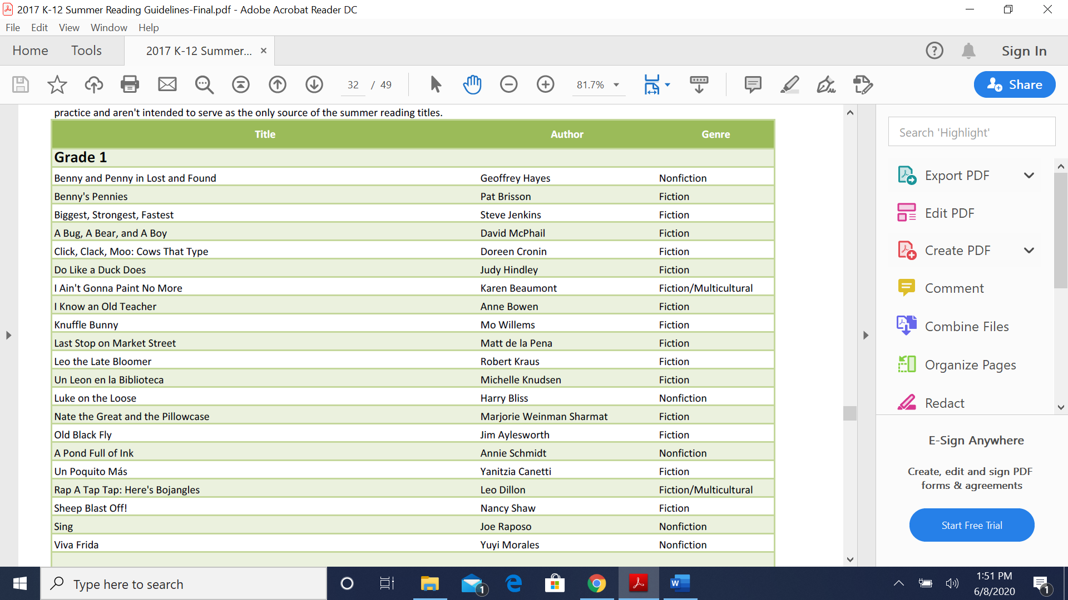

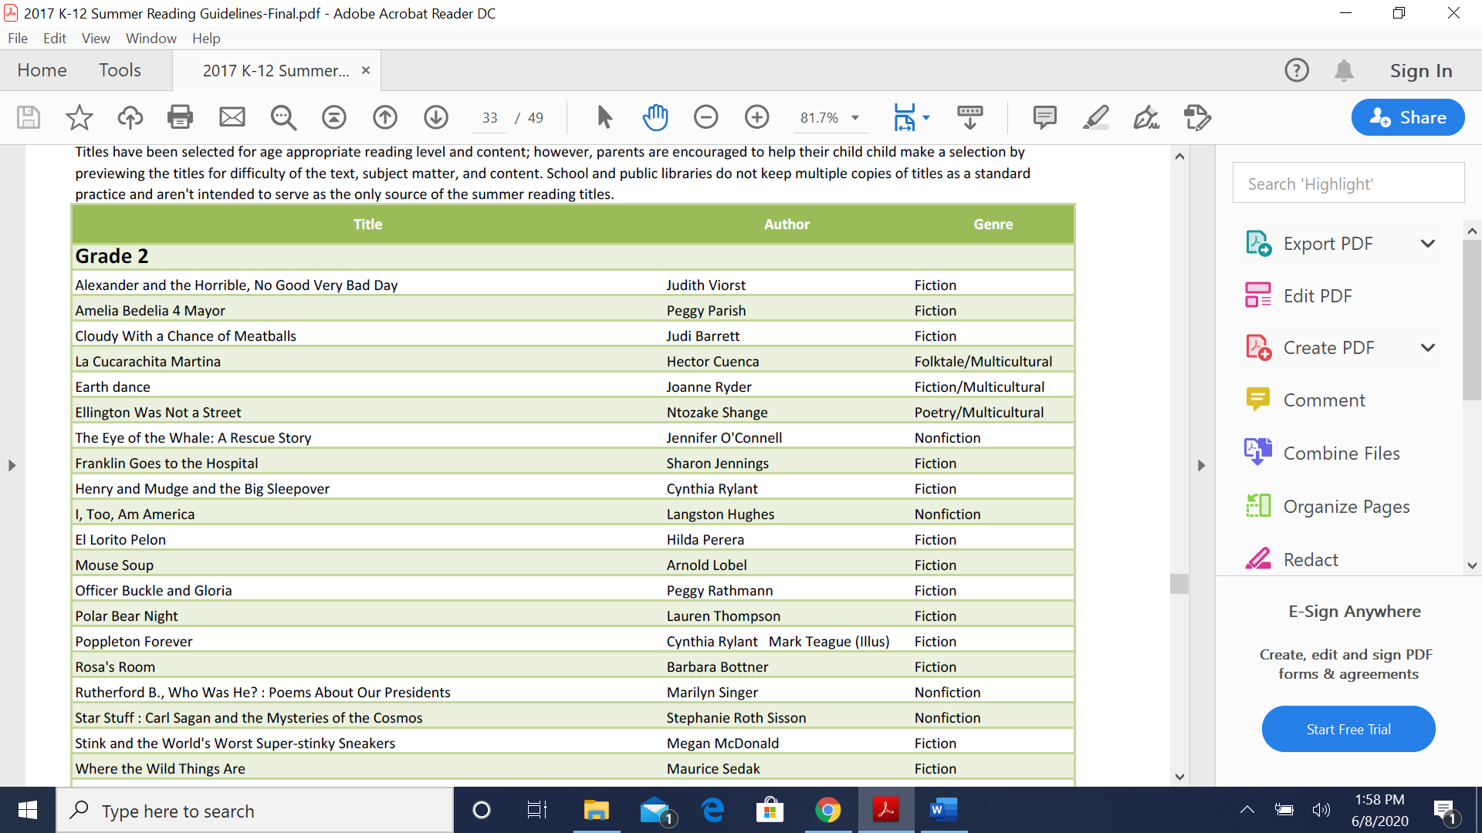

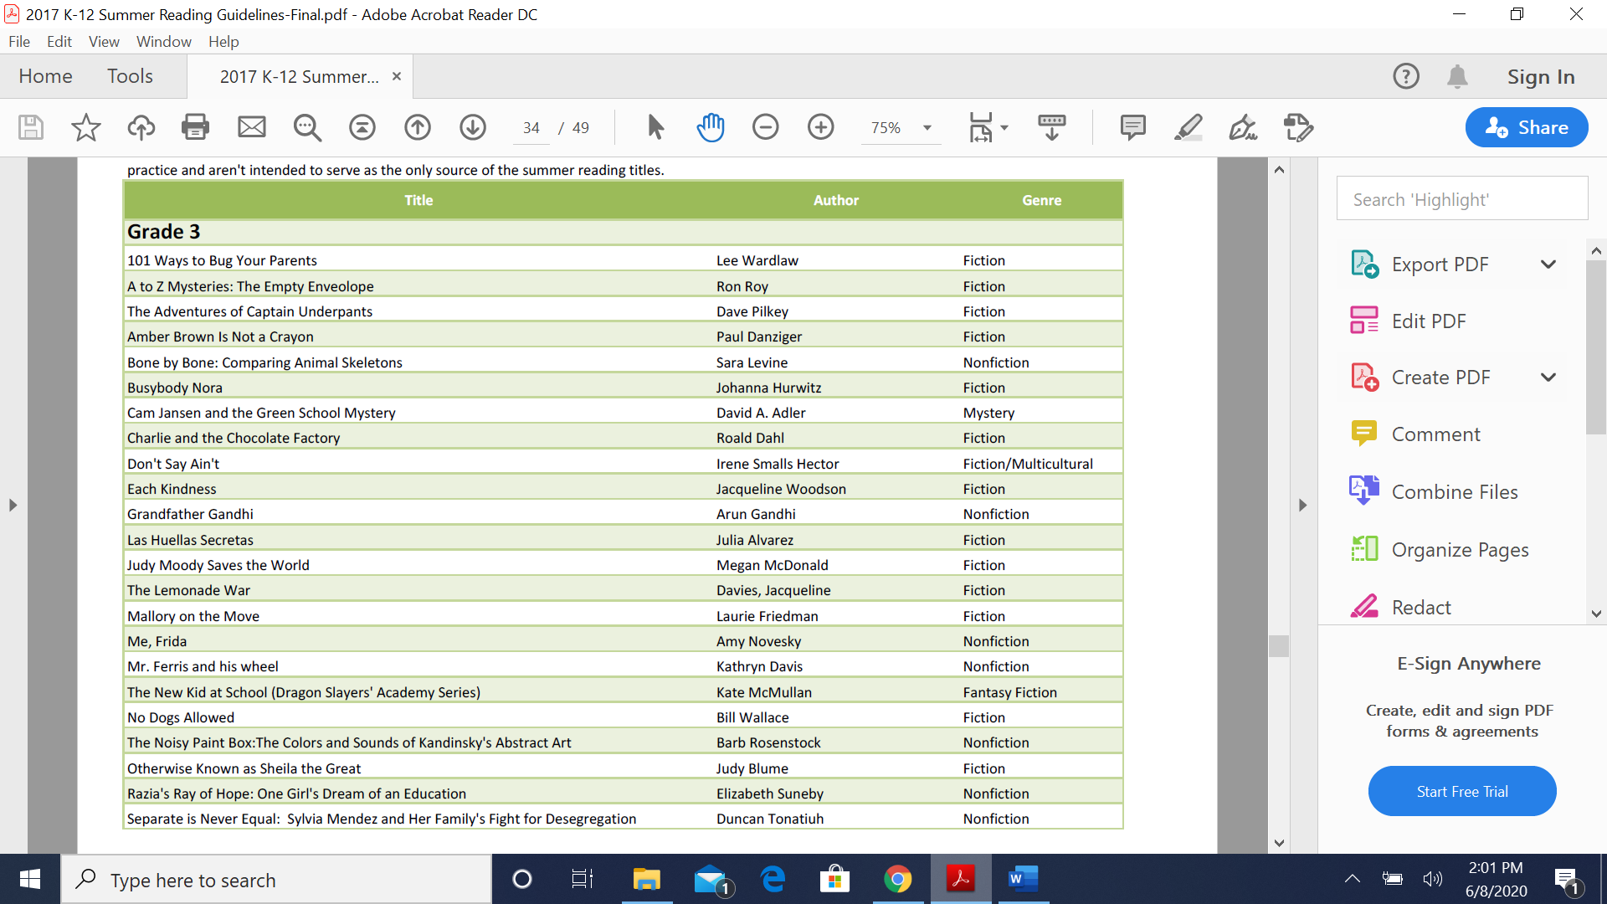

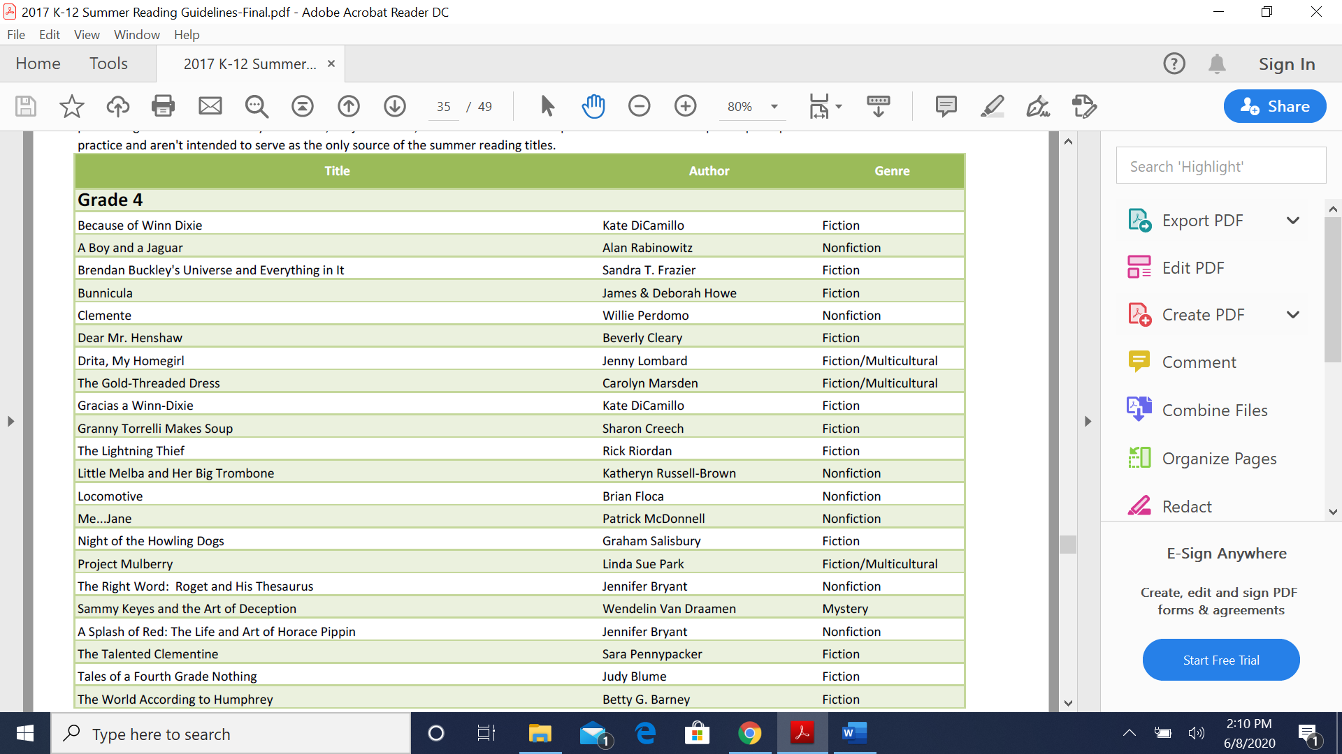

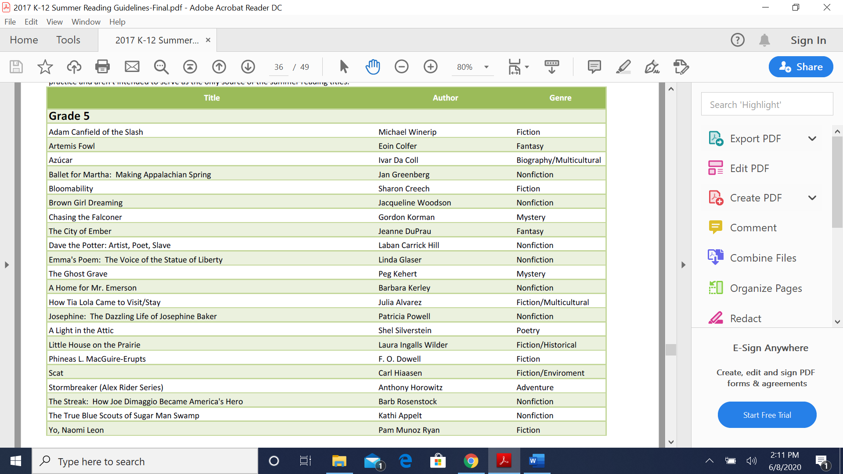

**6-8**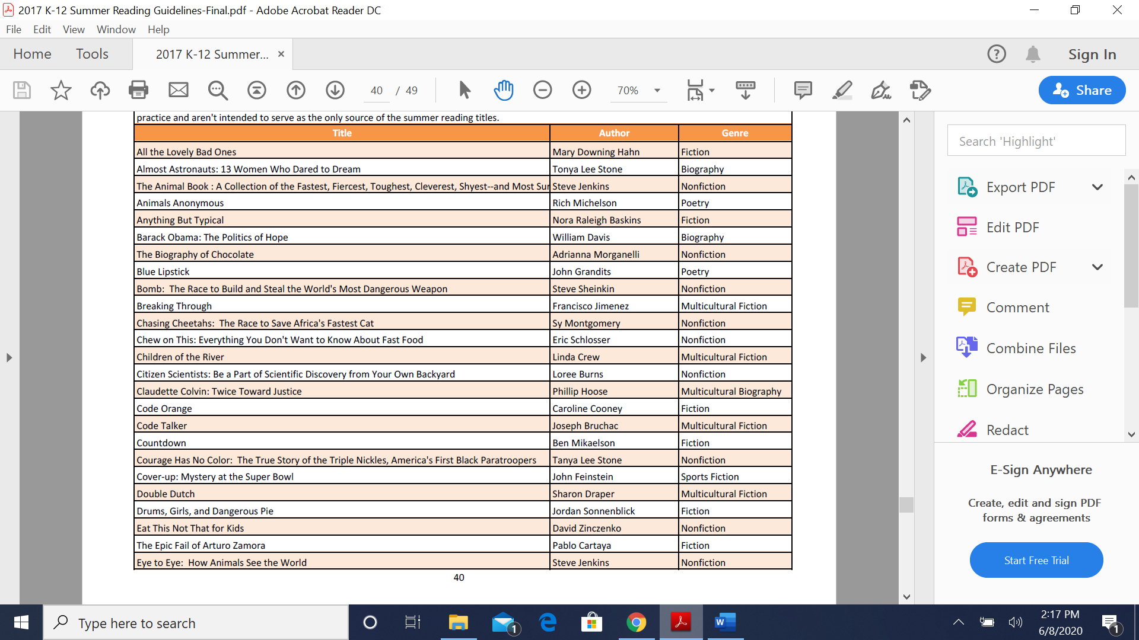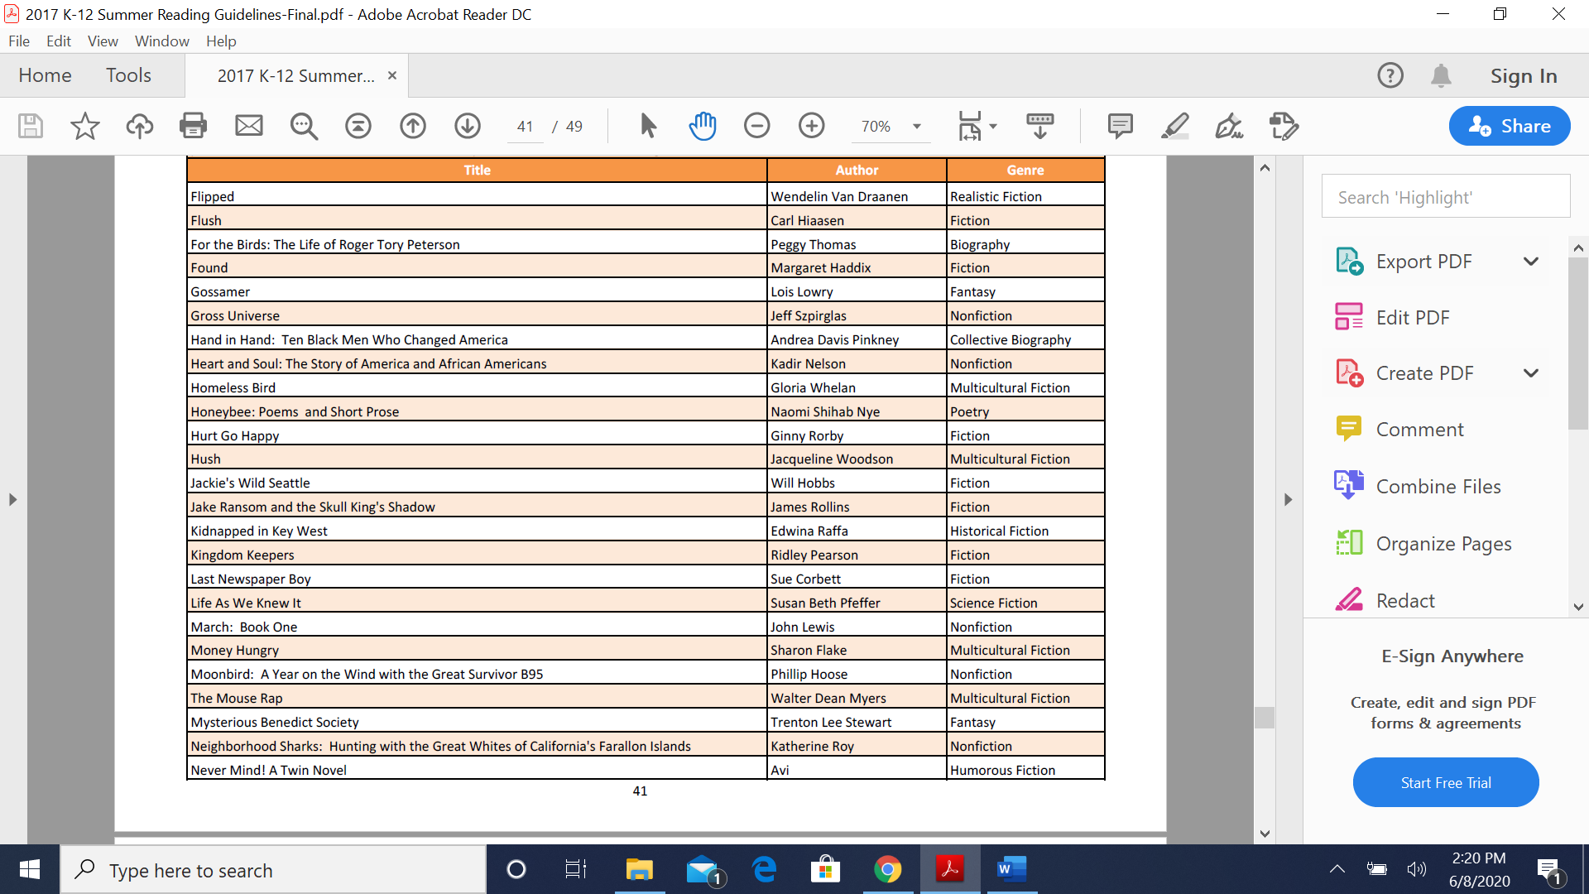

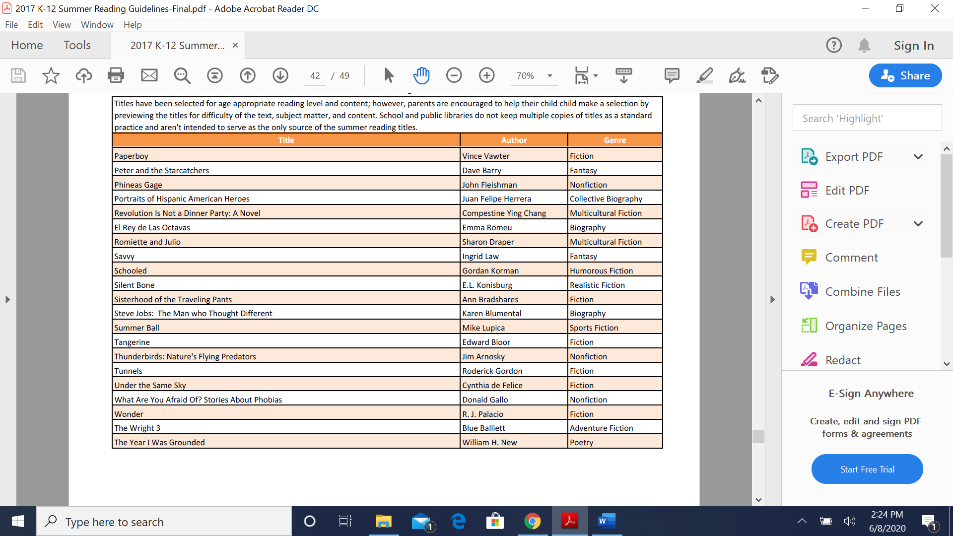

**9-10**

